4.3 TEST MS
1. (a) (i) Expression for Ka Ka = 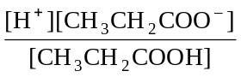 (1)
(ii) Expression for pKa pKa = –log10Ka (1)
(iii) Ka = 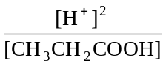 (1)
[CH3CH2COOH] = 0.10 M (1)
∴[H+] = (1) (0.1 × 1.35 × 10–5)
= 1.16 × 10–3 (1)
∴pH = 2.93 (1) 6
(b) [CH3CH2COO–] high or CH3CH2COO– strong electrolyte (1)
CH3CH2COO– ions react with H+ (1)
CH3CH2COOH weak acid or very little dissociated (1) 3
[9]

2. (a) HA H+(aq) + A–(aq) or HA + H2O H3O+ + A– (1) 1
(b) Ka = [H+][A–]/[HA] or Ka = [H3O+][A–]/[HA] (1) 1
(c) (i) Increases (1)
(ii) Decreases (1)
(iii) No change (1) 3
(d) Sodium ethanoate or sodium hydroxide (1)
Buffer solution (1) 2
[7]

3. (a) Kw = [H+][OH–] 1
(b) pH = –log10[H+] 1
(c) pH = –log10(2.00)
= – 0.30 1
(d) [H+] = 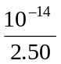 = 4.0 × 10–15 mol dm–3 (1)
∴pH = 14.40 (1) 2

(e) number of moles of acid and base:
H+ =19.0 × 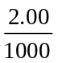 = 0.0380 & OH– = 16.0 × 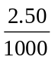 = 0.0400 (1)
Total volume:
V = 19.0 + 16.0 = 35.0 cm3 (1)
Concentration and pH:
∴XS [OH–] = (0.0400 – 0.0380) (1) × 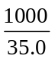 (1) = 0.0571 M (2)
∴[H+] = 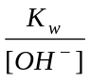 = 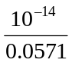 = 1.75 × 10–13 M (1)
∴pH = 12.76 (1) 6
[11]

4. (i) H+ or proton acceptor (1)
CH3NH2 + H2O () CH3+NH3 (+) OH– (1)
(ii) CH3NH3Cl or HCl (1)
Or any ammonium compound or strong acid
name or formula
(iii) extra OH– reacts with 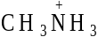
or reaction / equilibrium moves to left
or ratio salt / base remains almost constant (1)
Any 2
5
[5]

5. (i) NaHSO3 1
(ii) NaHSO3 + NaOH → Na2SO3 + H2O
or 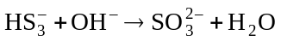 1

(iii) Phenolphthalein or alizarin yellow or thymol blue 1
[3]

6. (a) before any KOH added: Ka = 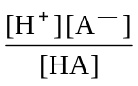 or 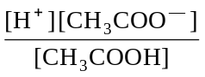 (1)
∴ Ka = 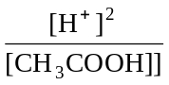 (1)
∴[H+] = 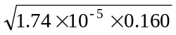 = 1.67 × 10–3 (1)
∴pH = 2.78 (1) 4

(b) at 8 cm3 KOH:
Moles KOH added = (8 × 10–3) × (0.210 = 1.68 × 10–3 (1)
∴ moles of CH3COO– formed = 1.68 × 10–3 (1)
Original moles of CH3COOH = (25 × 10–3) × 0.160 = 4.0 × 10–3 (1)
∴ moles of CH3COOH left = (4.0 × 10–3) – (1.68 × 10–3)
= 2.32 × 10–3 (1)
[H+] = Ka × 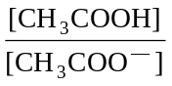 (1)
= 1.74 × 10–5 × 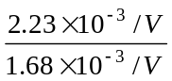 = 2.40 × 10–5 (1)
∴pH = 4.62 (1)
It forget subtraction : max 5
If Ka expression not used max 5
if moles of CH3COOH wrong but substitution used max 5
7
(c) at 40 cm3 of KOH:
Total moles of KOH = (40 × 10–3) × 0.21 = 8.4 × 10–3 (1)
∴ excess moles of KOH = (8.4 × 10–3) - (4.0 × 10–3)
= 4.4 × 10–3 (1)
in total volume = 40 + 25 = 65 cm3 (1)
∴ [OH–] = 4.4 × 10–3 × 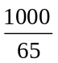 = 0.0677 (1)
∴ [H+] = 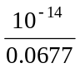
OR pOH =1.17
= 1.477 × 10–13 (1)
∴pH = 12.83 (1)
If volume missed : max 4
If moles of acid wrong but method includes subtraction : max 5
If no subtraction : max 4
5
[Max 15]

